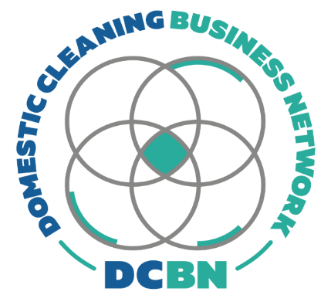
SSP CHANGES
IMPLEMENTATION CHECKLIST

Before April 2026
- Confirm who is an employee vs subcontractor
- Replace old contracts with the updated templates
- Issue the updated sickness/absence policies and confirm receipt
- Set up your absence tracking (log or spreadsheet)
- Train your team/manager on:
  - call-only reporting
  - return-to-work interviews
  - trigger points and review meetings
- Decide your cover plan process for short-notice sickness
- Assess current sickness absence rates and if any action should be taken

From April 2026 onwards
- Apply Day 1 SSP rules as required by law
- Log every absence the same day
- Run RTW interviews on first day back
- Review triggers weekly (or at least monthly)
- Escalate repeat absence into a formal sickness review meeting

Ongoing (monthly)
- Audit your absence log for patterns
- Check fit notes are complete and filed
- Refresh staff reminders about reporting rules

